Project Topic: Railway Management System

Subject Name: Software Engineering Lab

Subject Code: CS693

Name: Ishita Mukherjee

University Roll Number: 430118020047

Class Roll No: 47

**Railway Management System**

**1.Introduction**

In our country India, there are number of counters for the reservation of the seats and one can easily make reservations and get tickets. Then this project contains entity relationship model diagram based on railway management system and introduction to relation model. There is also design of the database of the railway management system based on relation model.

The Railway Management System facilitates the passengers to enquire about the trains available on the basis of source and destination, booking and cancellation of tickets, enquire about the status of the booked ticket, etc. The aim of case study is to design and develop a database maintaining the records of different trains, train status, and passengers.

**1.1 Purpose**

The purpose of Railway Reservation System is to create Reservation, Cancel Reservation, Viewing Train Information, Viewing Reservation Details, Updating Train Information, Updating Reservation Details and Generate Reports.

**1.2 Scope**

1. Creating reservation
2. Cancel reservation
3. View reservation status
4. View train schedule
5. Update train schedule
6. Update reservation details

**1.3 Definition, Acronym, Abbreviation**

* SQL -> Structured Query Language
* DFD -> Data Flow Diagram
* CFD ->Context Flow Diagram
* ER ->Entity Relationship
* IDE ->Integrated Development Environment
* SRS ->Software Requirement Specification

**2. Overall Description**

**2.1 Product Perspective**

1. The website gets the details from the passenger and it checks whether

the seats are remaining in order to confirm the Reservation.

If the seats are available, then it allocates the seat to the passenger by giving the reservation confirmation to the passenger.

If seats are not available, it places the reservation in waiting List.

1. The website gets the details from the passenger in order to cancel the

reservation and cancels the reservation. It also updates the reservation details after

cancelling the reservation and it updates the waiting List.

1. The administrator updates the train information and the website generates the new schedule of the train, reservation details.

**2.2 Software Requirement**

* **Front end:**

1. HTML
2. CSS
3. JAVA SCRIPT
4. Web interface

* **Back end:**

1. MySQL
2. PHP

**2.3 Hardware Requirement**

* 1. 4 GB ram
  2. 1.2 GHz processor
  3. Intel i5
  4. Windows 7/8/8.1/10

**2.4.1 Functional Requirement**

**R.1: Register**

* + Description: First the user will have to register/sign up. There are two different type of users.
  + The railway staff and regular person: They have to provide details about the name address, phone number, and email id.

**R.1.1: Sign up**

* Input: Detail about the user as mentioned in the description.
* Output: Confirmation of registration status and a username and a password will be generated and mailed to the user.
* Processing: All details will be checked and if any error is found then an error message is displayed else a username and a password will be generated.

**R.1.2: Login**

* Input: Enter the username and password provided.
* Output: User will be able to use the features of software.

**R.2: Create reservations:**

A passenger should be able to reserve seats in train. A reservation form is filled up by the passenger and given to the website, which then checks for the availability of seats for the specified date of journey. If the seats are available then the entries are made in the system regarding the train name, train number, date of journey, boarding station, destination, person name, sex and total fare. Passenger is asked to pay the required fare and the tickets are printed. It the seats are not available then then the passenger is informed.

**R.3: Cancel reservations:**

A passenger is wishing to cancel a reservation is required to fill a form. The passenger then submits the form and the ticket to the website. The website then deletes the entries in the system and then changes the reservation status of the train.

**R.4: Update Train Info:**

Only the administrator enters any changes related to the train information like change in the train name, train number, train route etc. in the system.

**R.5: View Reservation Status:**

All the users should be able to see the reservation status of the train online. The users’ needs to enter the train number and pin number printed on his ticket so that the system can display his current reservation status like confirmed, RAC or Wait-Listed.

**R.6: View Train Schedule:**

Provision should be given to see information related to the train schedules for the entire train network. The user should be able to see the train name, train number, Boarding and destination stations, duration of journey etc.

**2.4.2 Non-Functional Requirements**

* **USABILITY REQUIREMENT:**  The system shall allow the users to access the system in the required platform. As it is a website, all a user wants to have an interface like google, Mozilla Firefox this kind of platform to run this. As all are well acquainted with this basic knowledge no special training is required. The site is user friendly.
* **AVAILABILITY REQUIREMENT:** The system is available 100% for the user and is used 24 hrs a day and 365 days a year. The system shall be operational for 24×7.
* **EFFICIENCY REQUIREMENT:** Mean Time To Repair (MTTR)- even if the system fails, the system will be recovered back up within an hour or less.
* **ACCURACY:** The system should accurately provide real time information taking into consideration various concurrency issues. The system shall provide 100% access reliability.
* **PERFORMANCE REQUIREMENT:** The information is refreshed depending upon whether some updates have occurred or not in the application. The system shall respond to the member in not to less than two seconds from the time of the request submission. The system shall be allowed to take more time when doing large processing jobs. Responses to view information shall take no longer than 5 seconds to appear on the screen.
* **RELIABILITY REQUIREMENT:** The system has to be 100% reliable due to the importance of data and the damages that can be caused by incorrect or incomplete data. The system will run 7 days a week, 24 hours a day.

**3.Diagrams**

**3.1 Use Case Diagram**

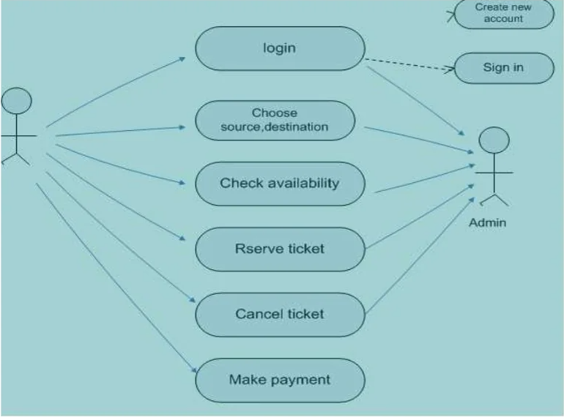

**3.2 Class Diagram**

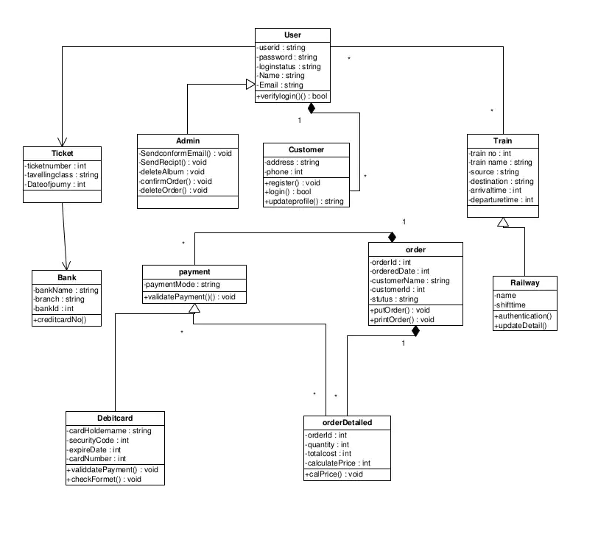

**3.3 State Diagram**

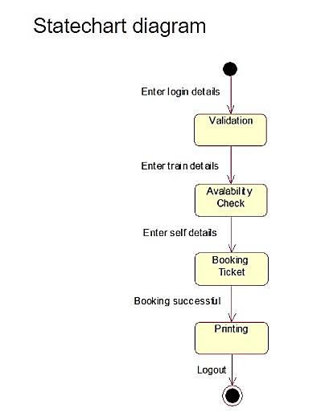

**3.4 Sequence Diagram**

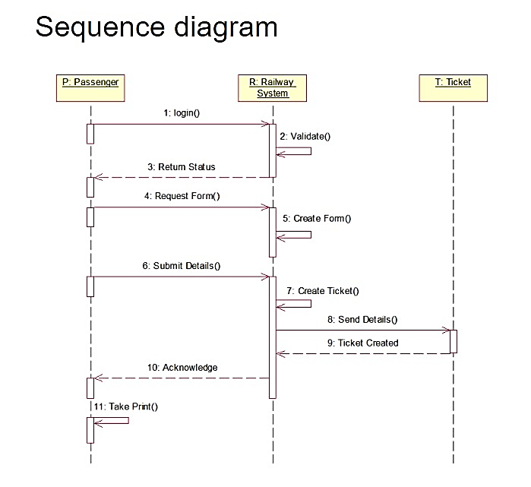

**3.5 Data Flow Diagram**

0-level DFD

**Up/Down Train Info**

**Admin**

**Railway Reservation**

**Ticket Info**

**Passenger**

**Login/Registration Info**

**Passenger info and Waiting Info**

**Ticket Reservation**

**Fill Cancellation Form**

1-level DFD:

Reservation storage file

Down Storage

Passenger

Up Storage

* 1. **ER Diagram**

**4.Screenshots of the Website**

**Home Page**

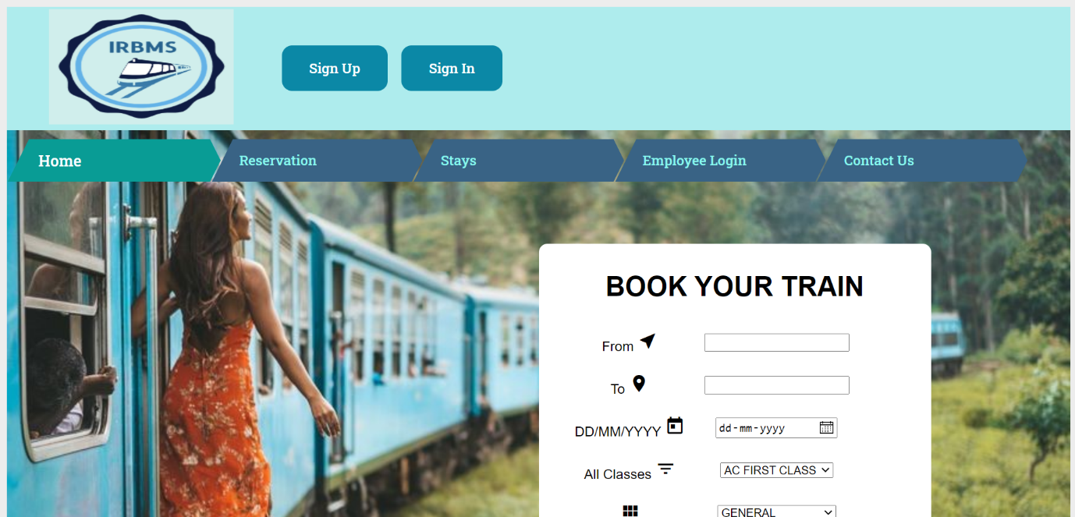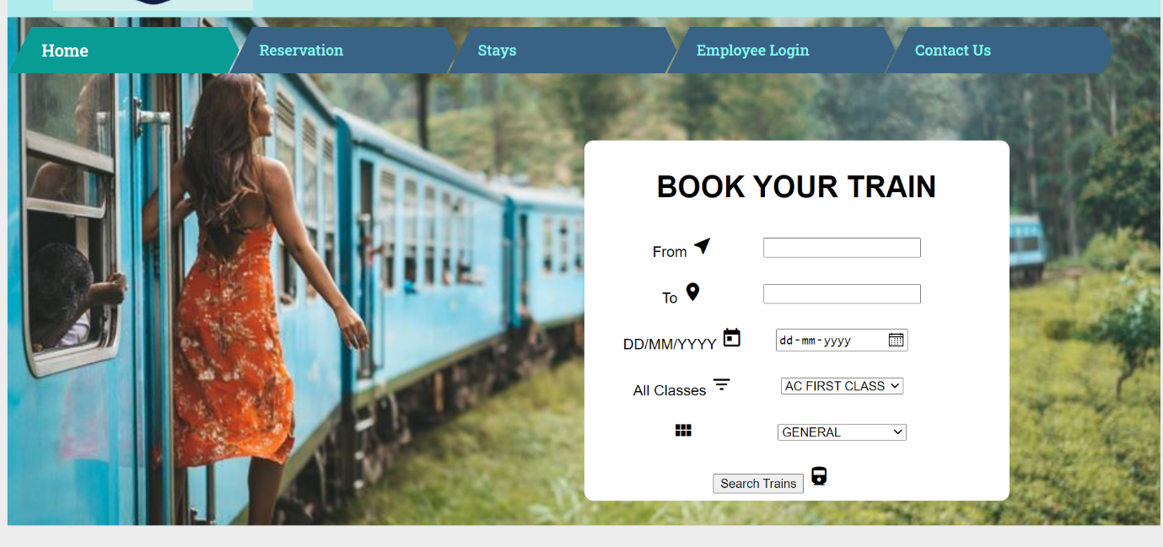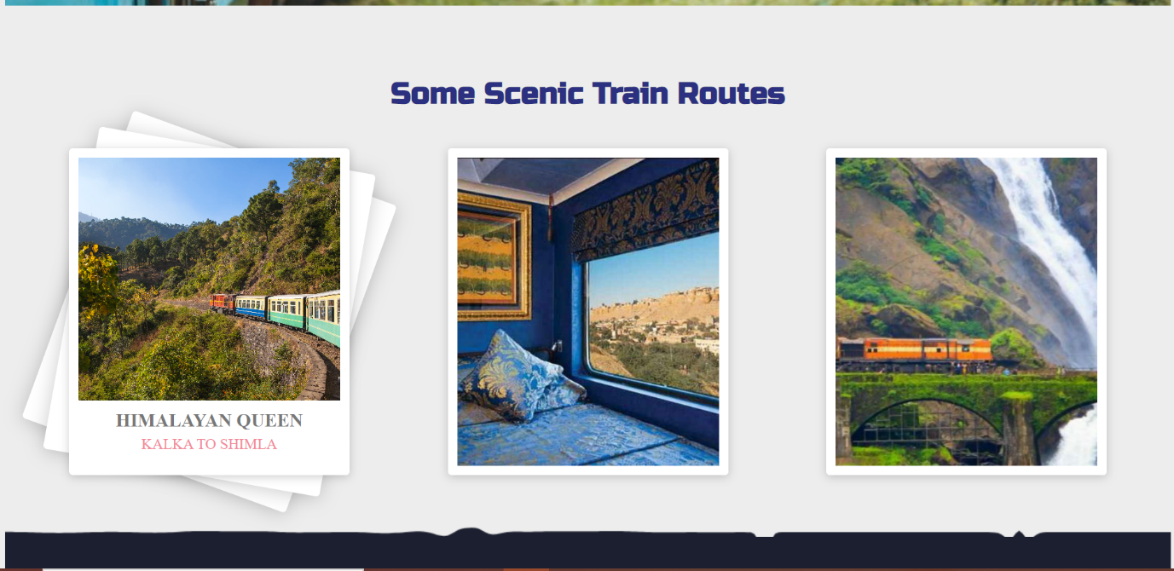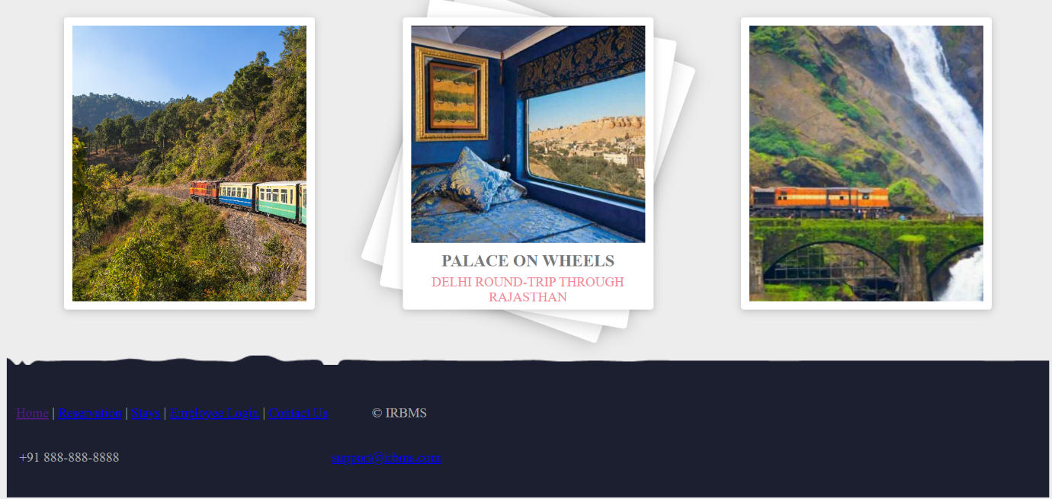

1.Selecting Source and Destination and date of travel

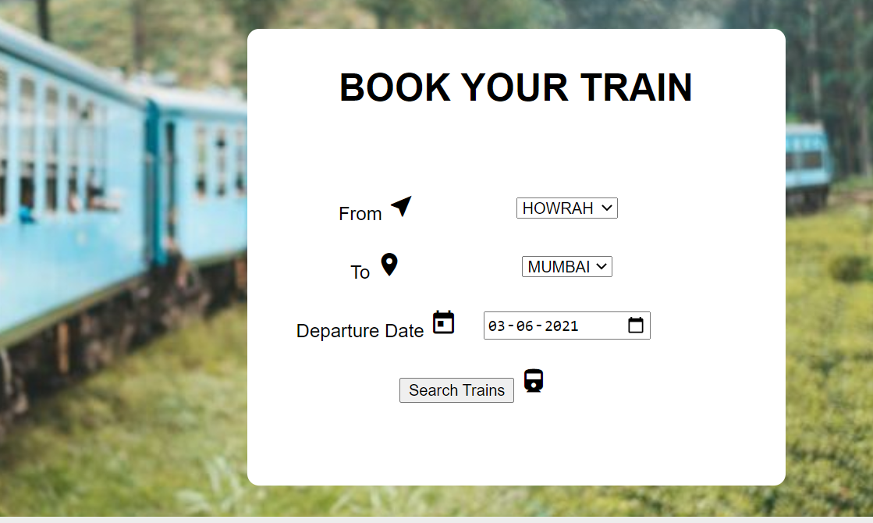

2. Selecting the train we want to travel by

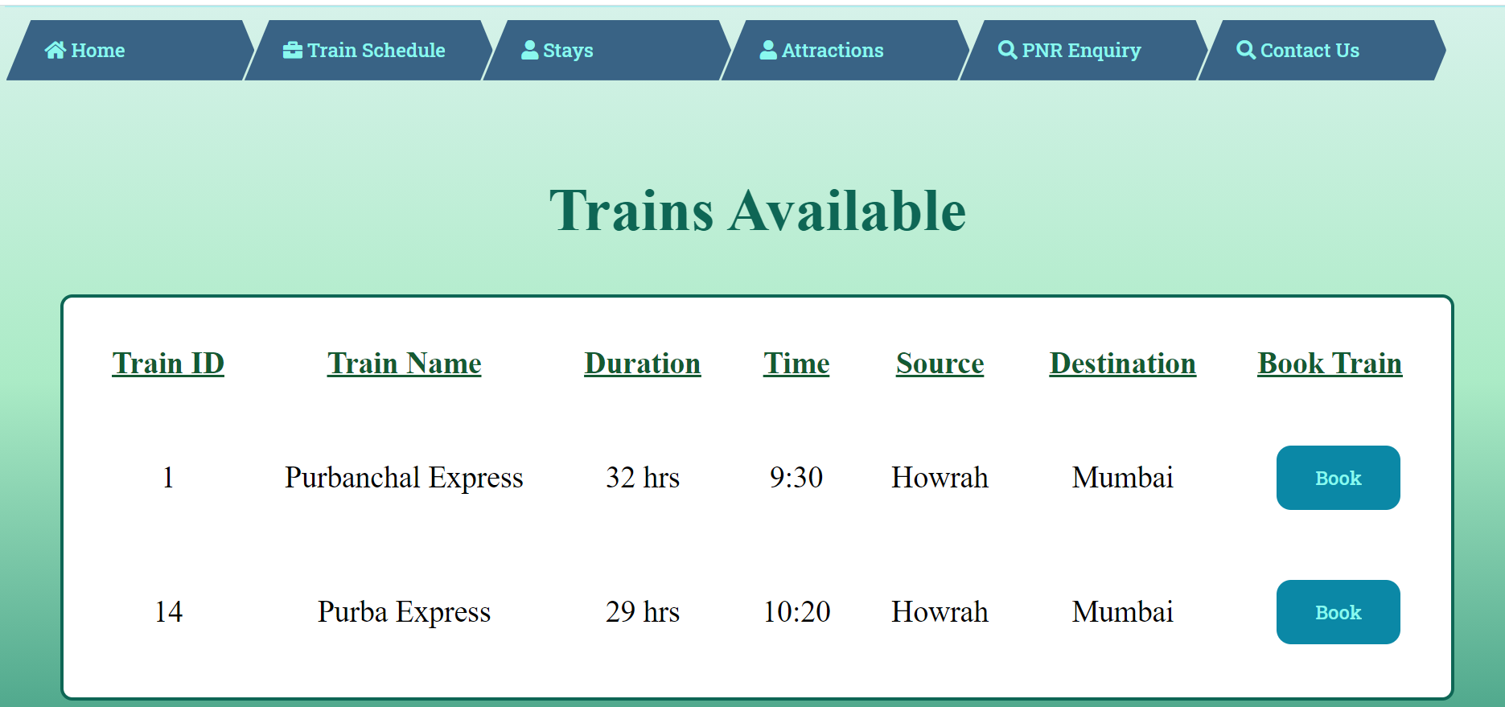

3. Selecting the seat type if available and entering the number of passengers

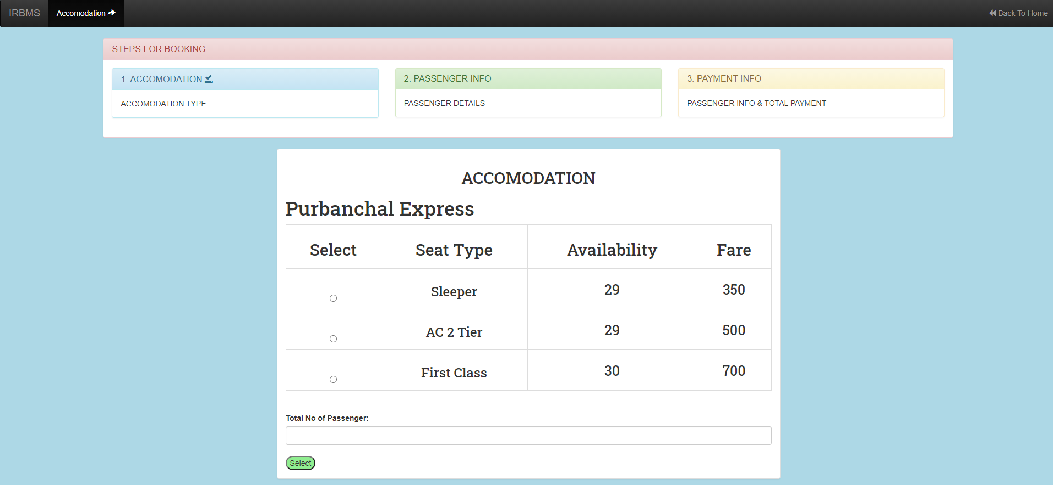

4. Entering the passenger details

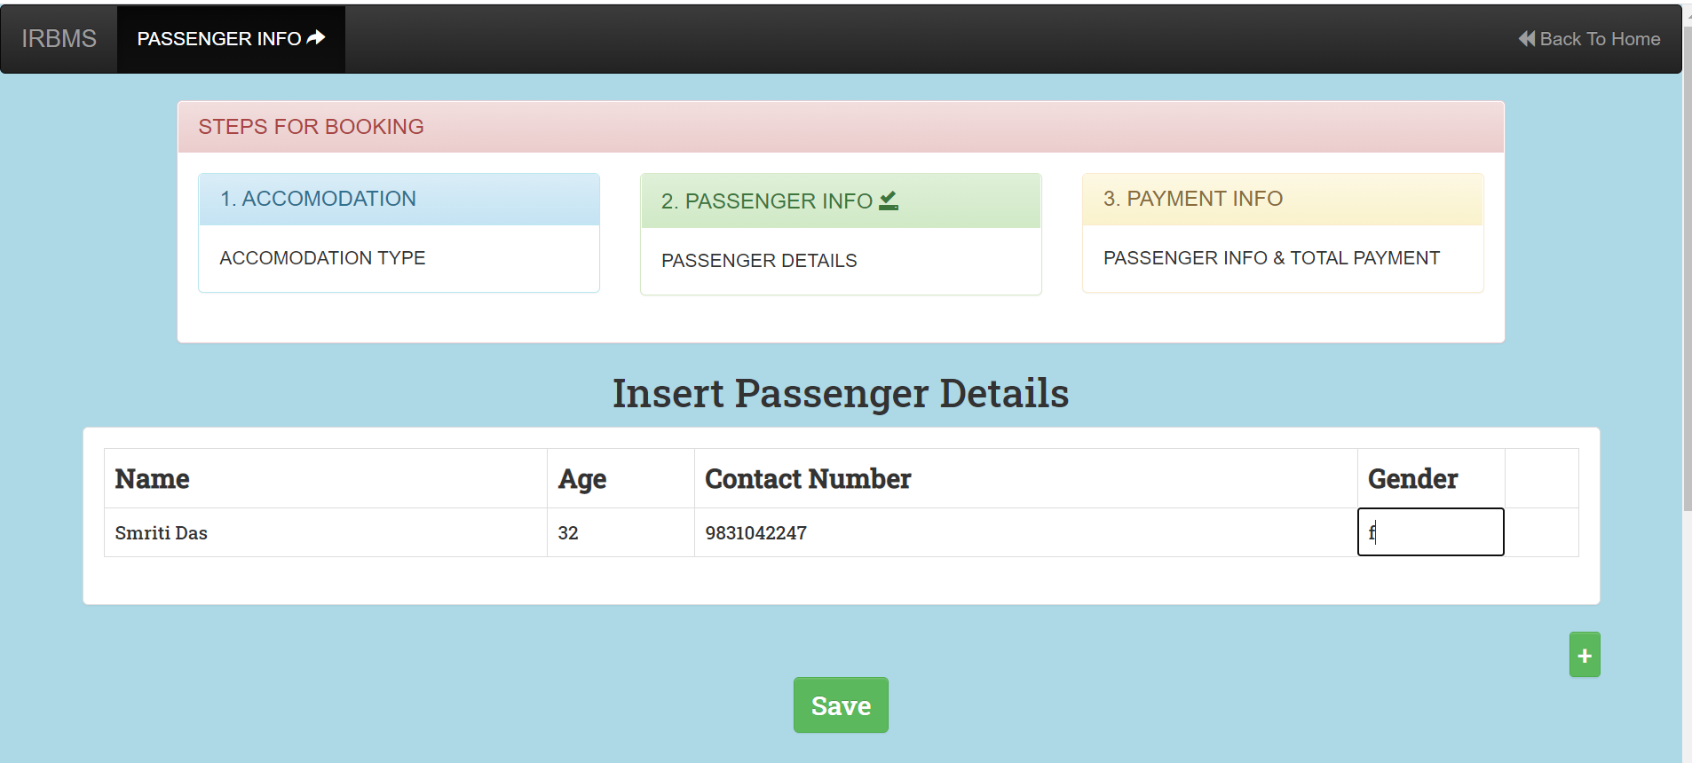

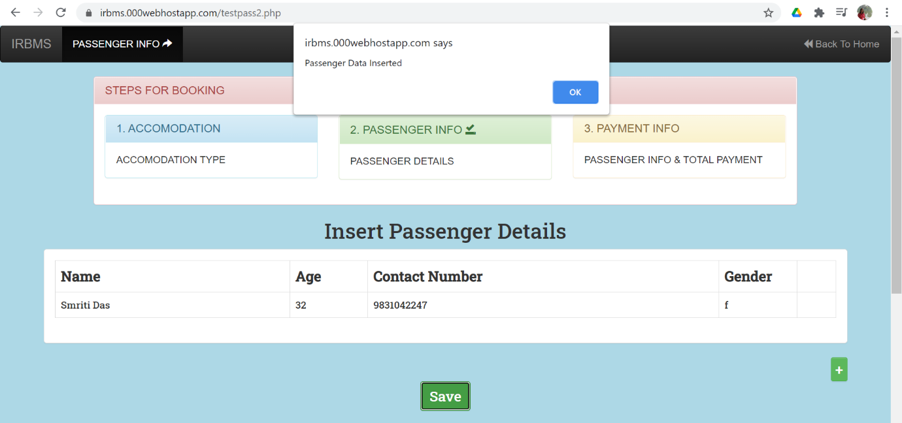5. Inserting Details of the person who is booking

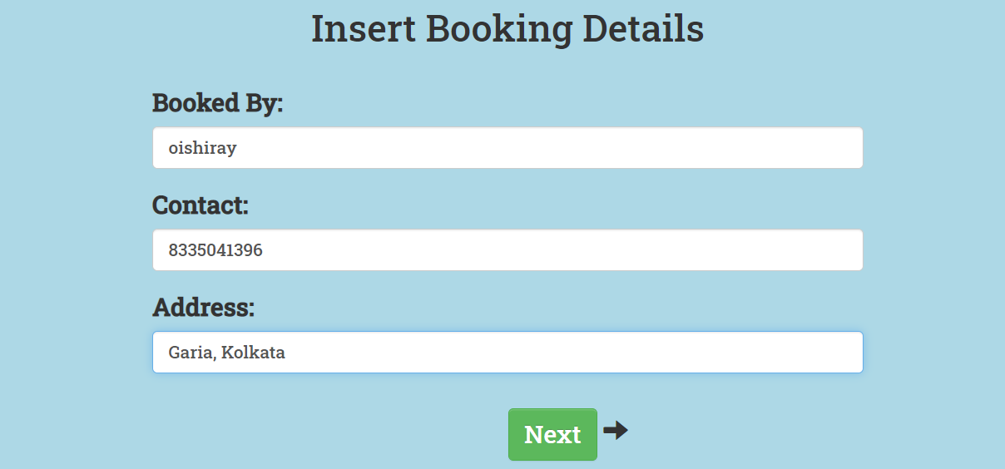

6. Showing the ticket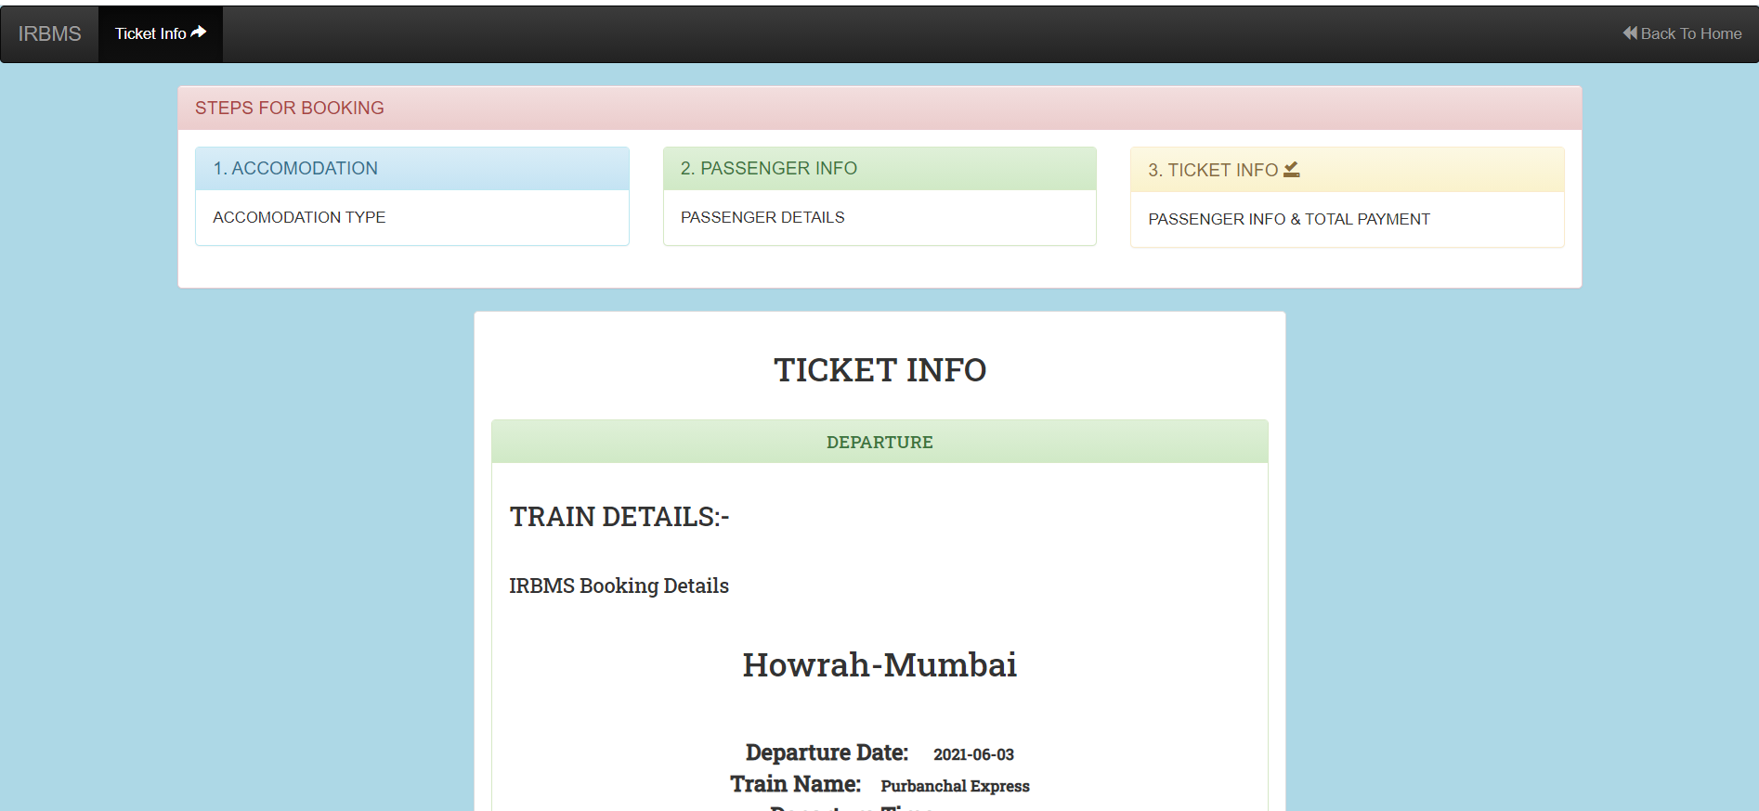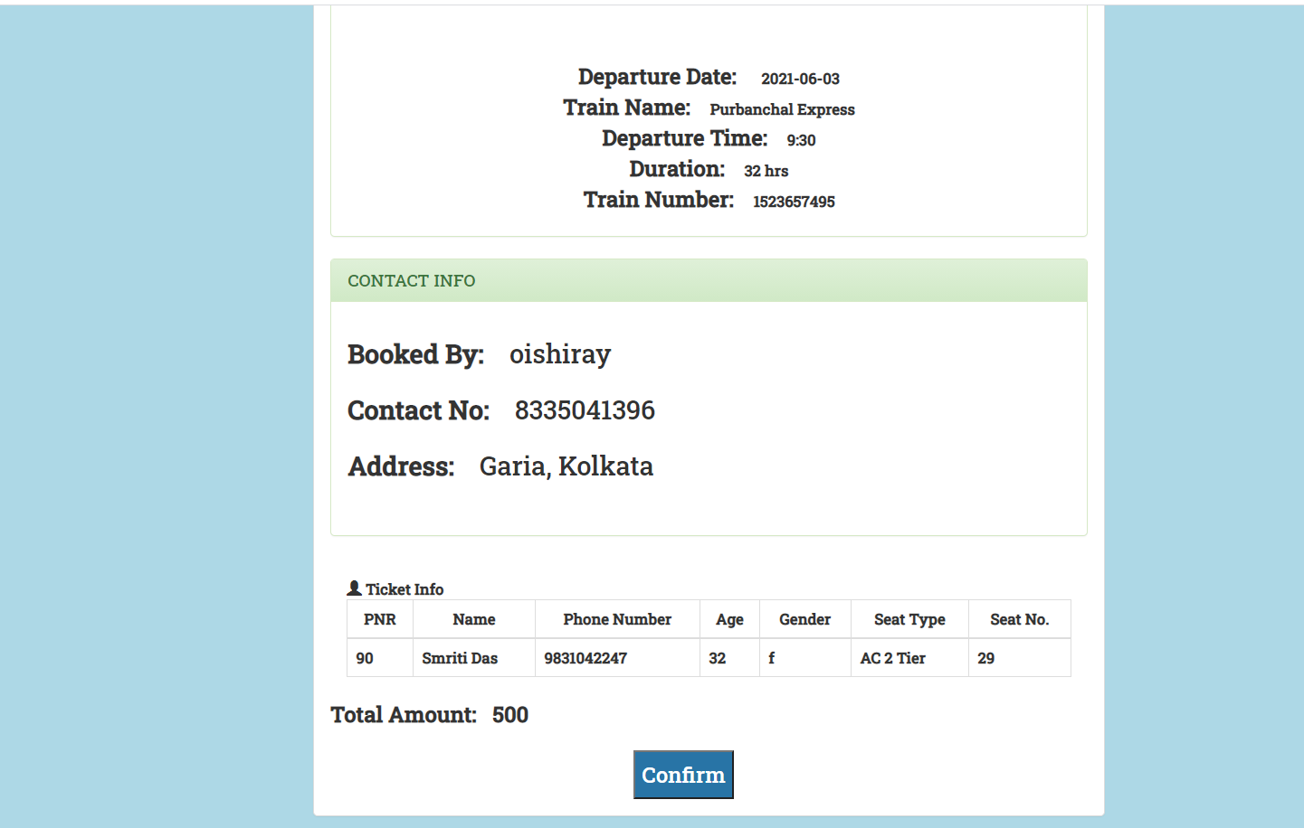

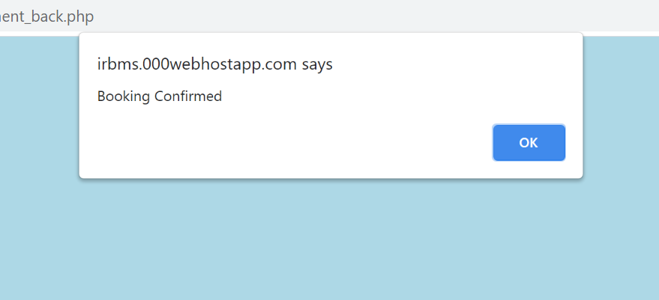

7. Payment portal

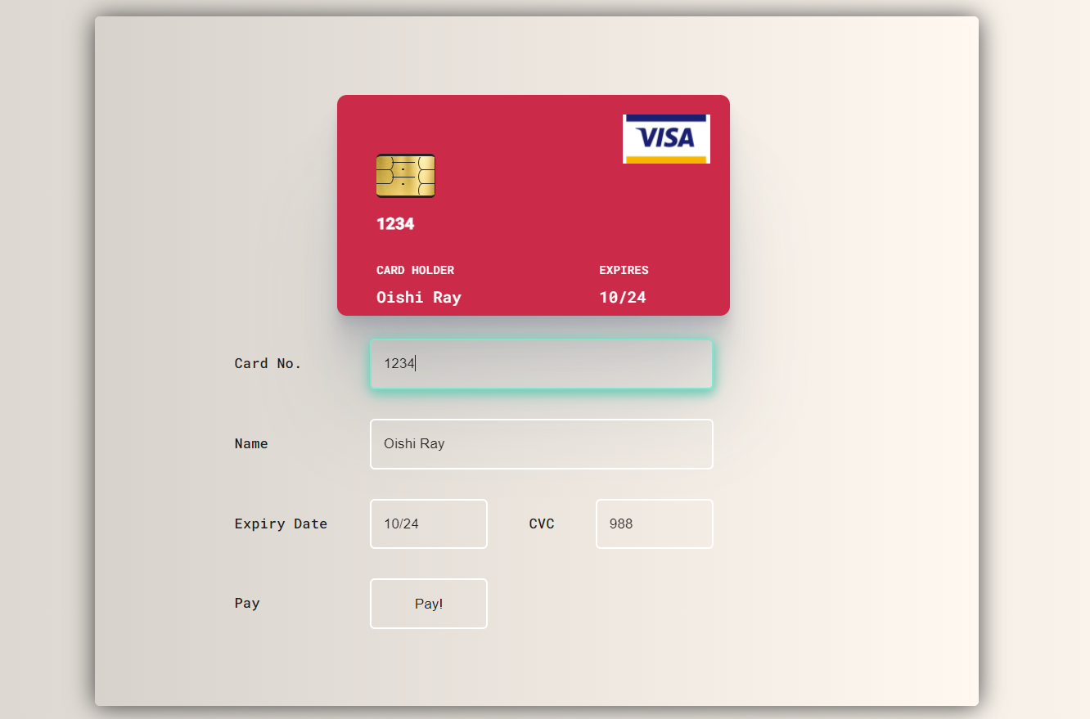

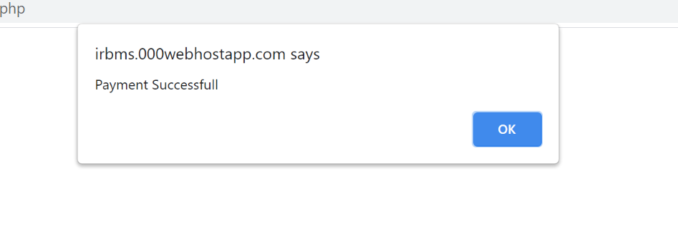

**Login Page**

**1. Log In Successful: for correct credentials**

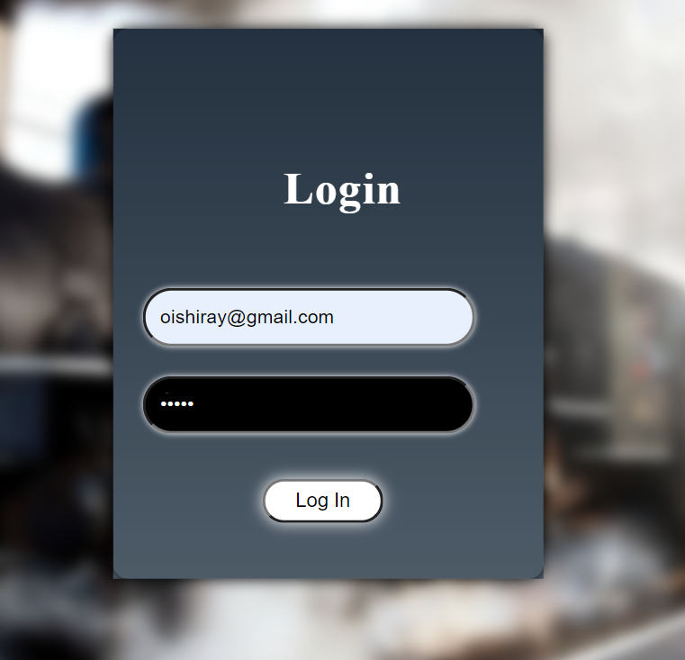

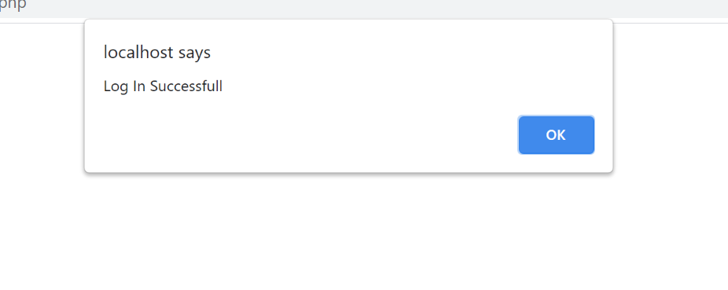

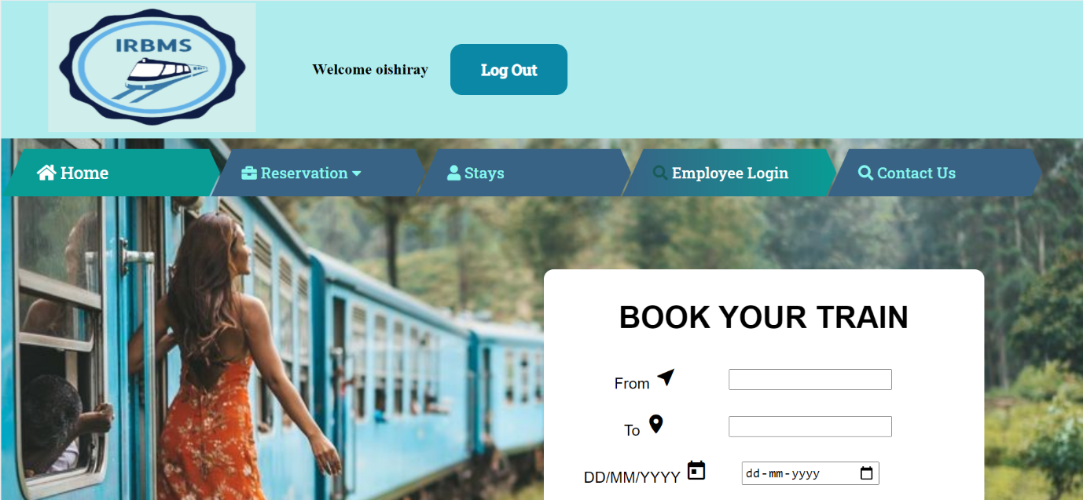

**2. If wrong password given**



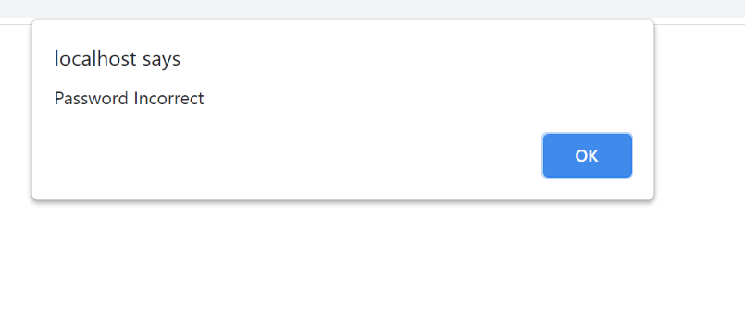

**3. If User does not have an account and tries to Log In**

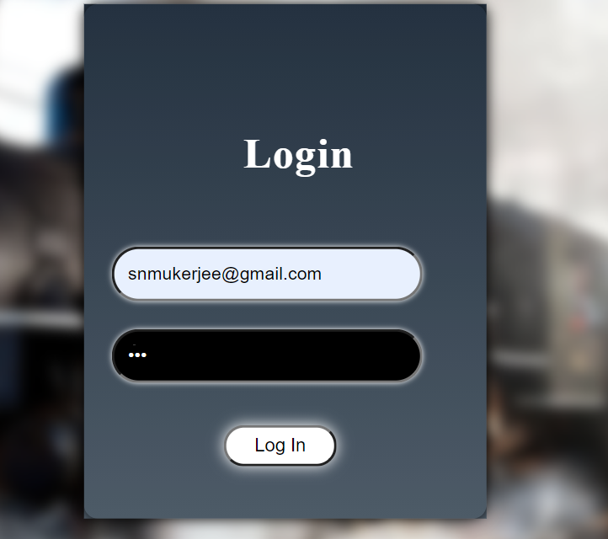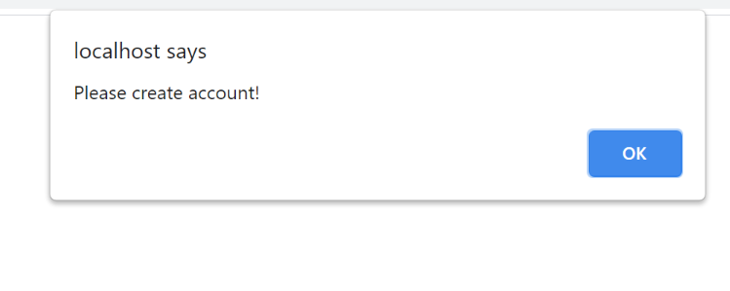

**4. If user presses submit without entering email or password**

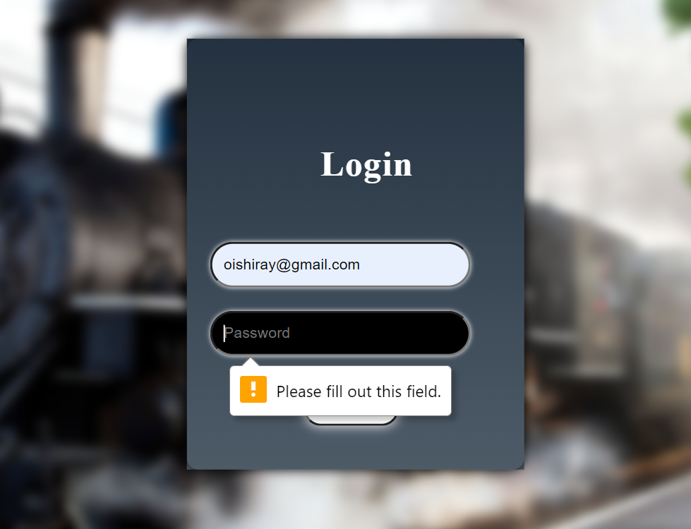

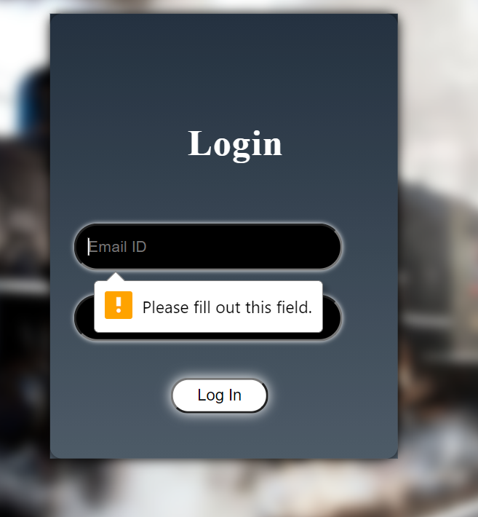

**Registration Module**

1. **Registration Successful**

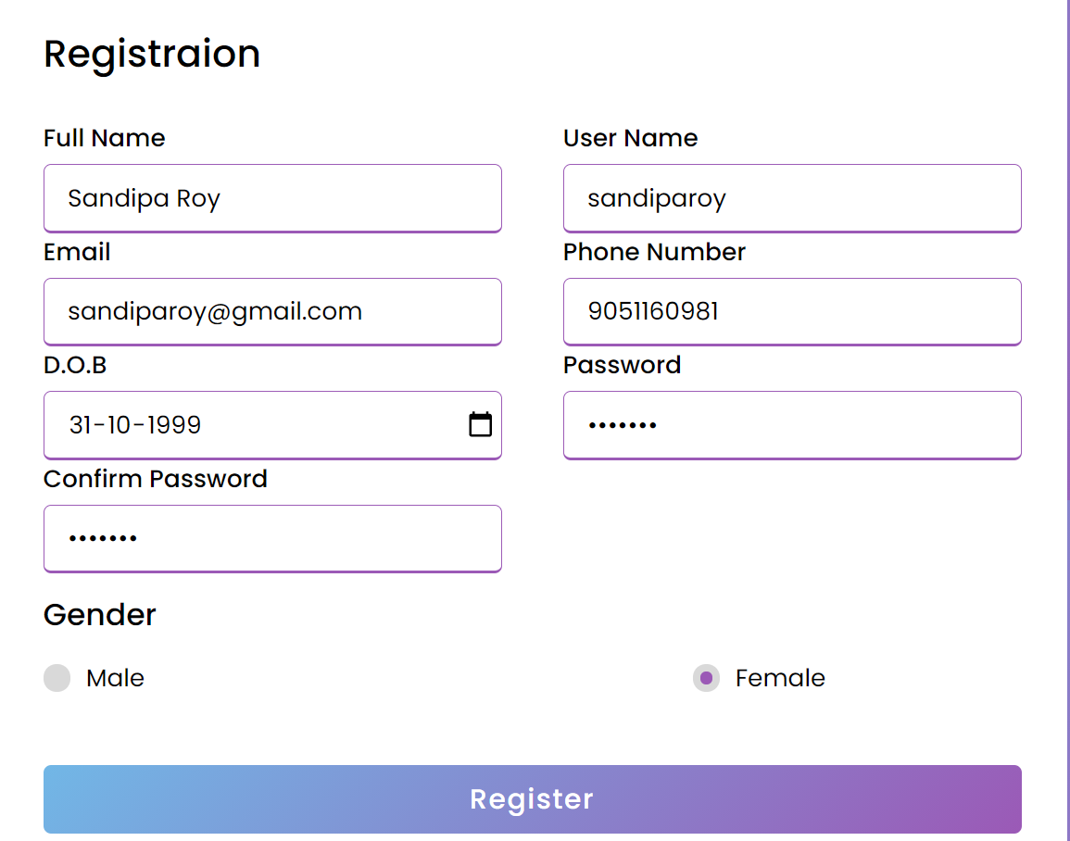

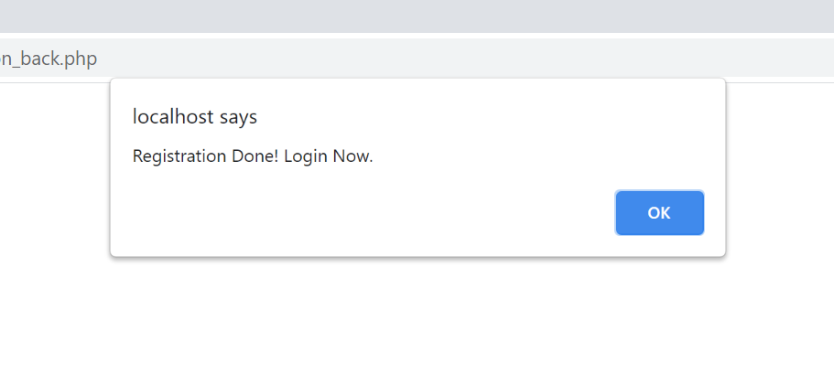

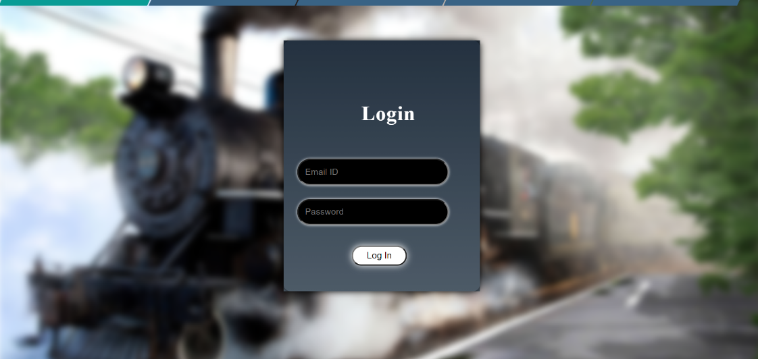

1. **If an old user wants to register again**



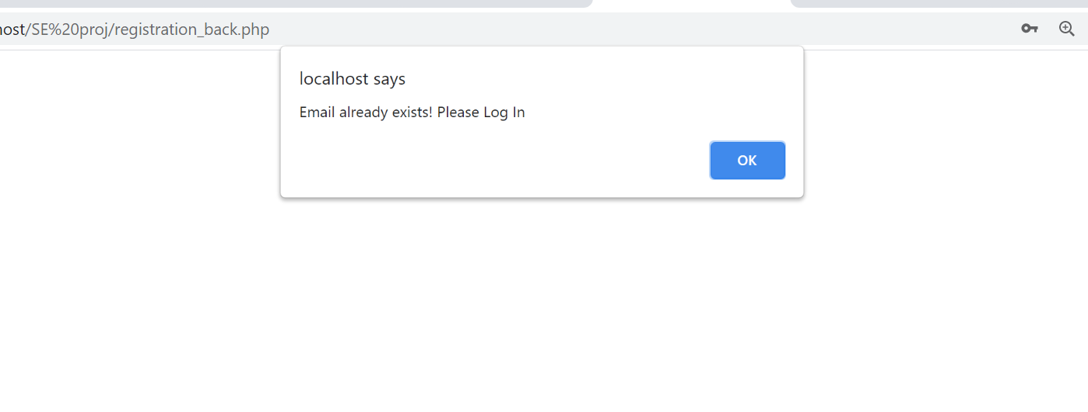

1. **If password and confirm passwords are not matching**

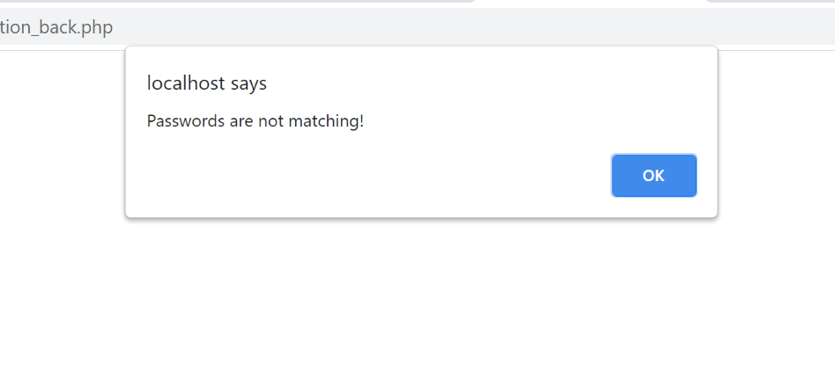

1. **If any field is left blank on the form**

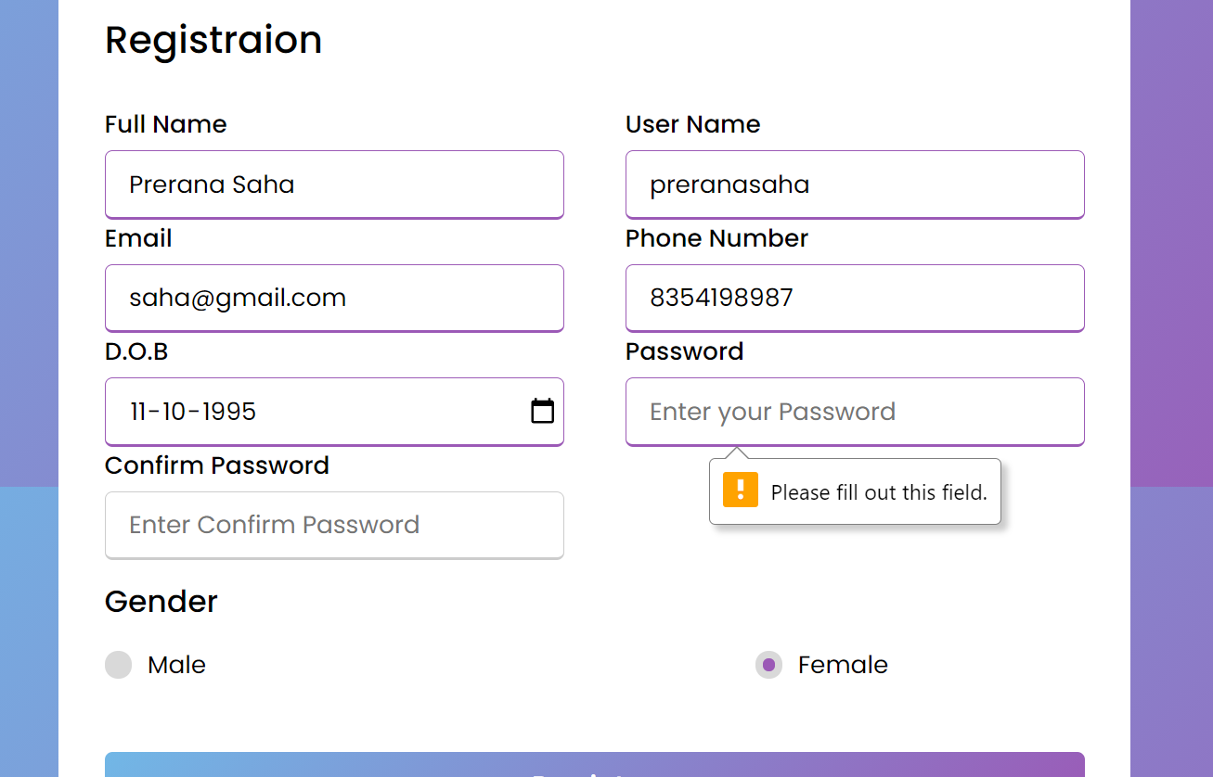

1.Admin Login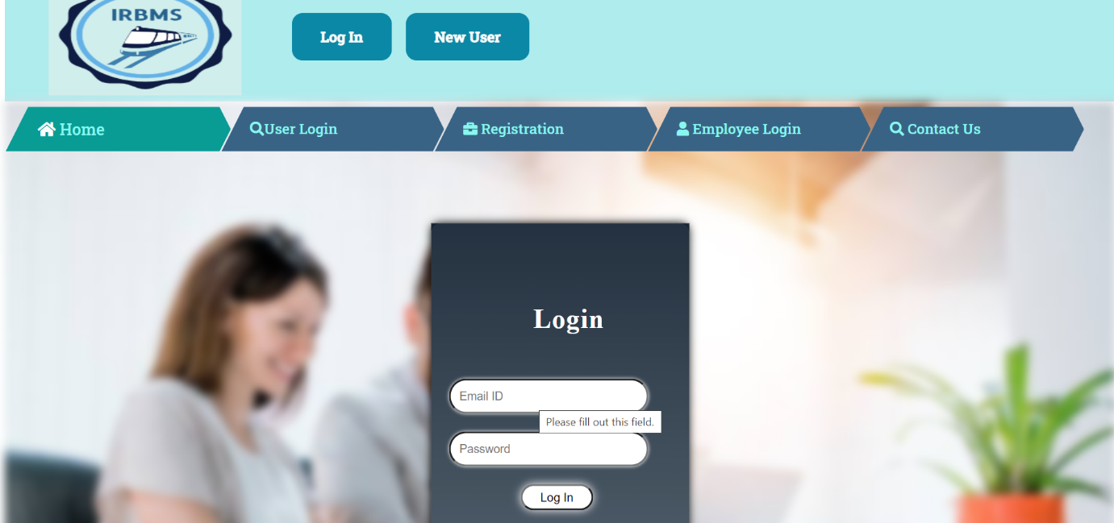

2.Login is not successful if any of the fields are missed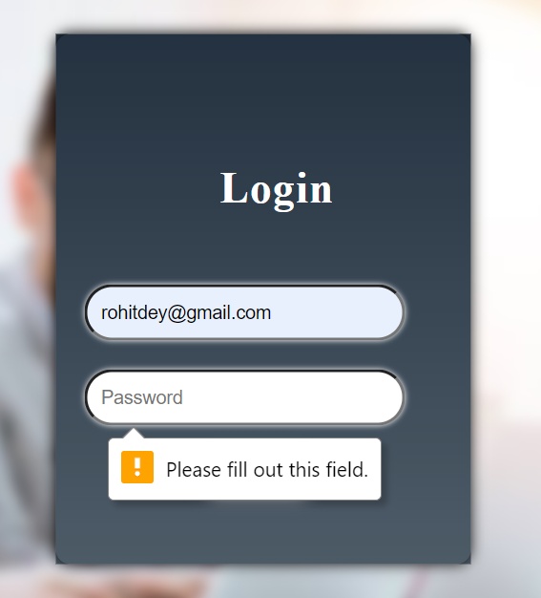

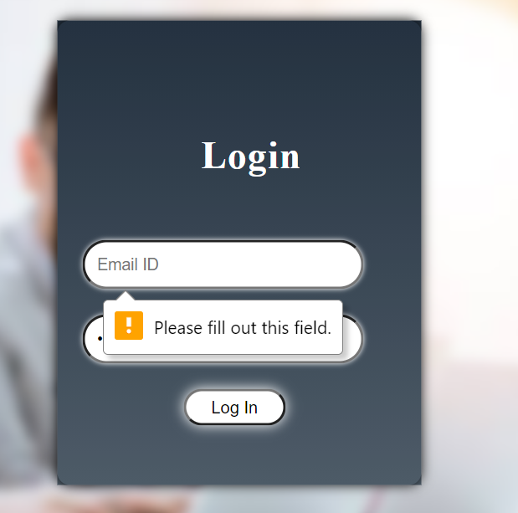

3.After providing correct credentials Login occurs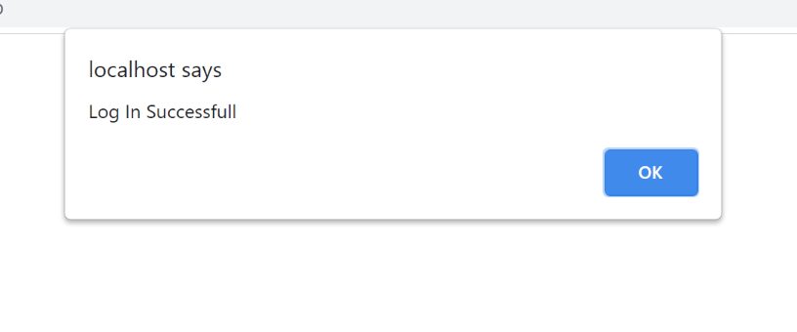

4. The admin Home Page opens

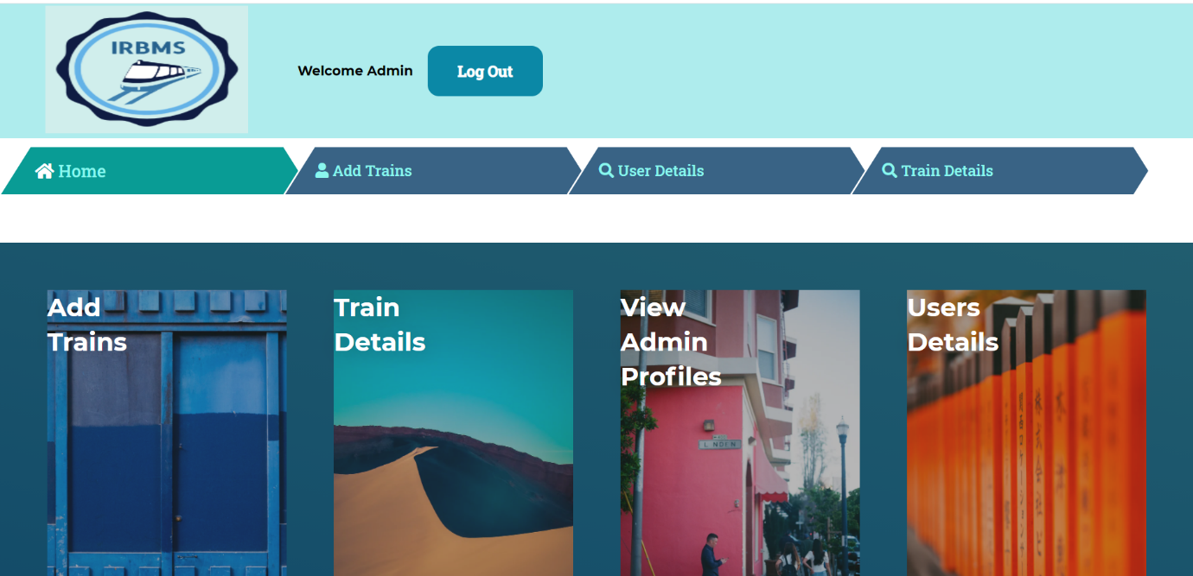

5.Add trains Module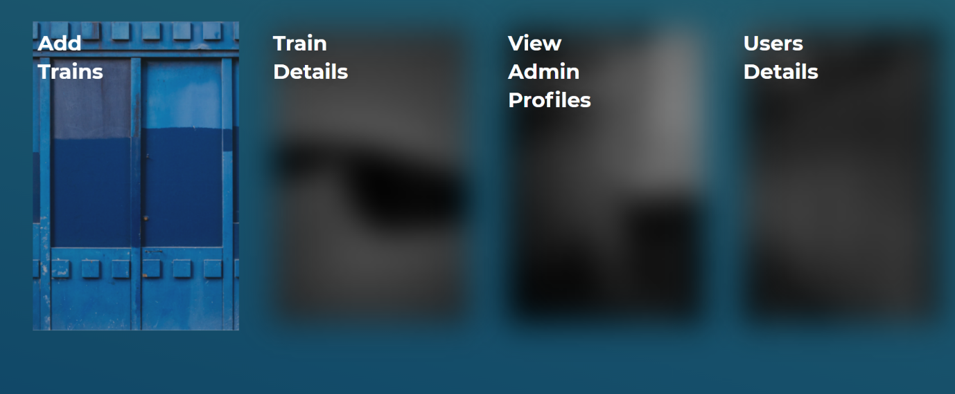

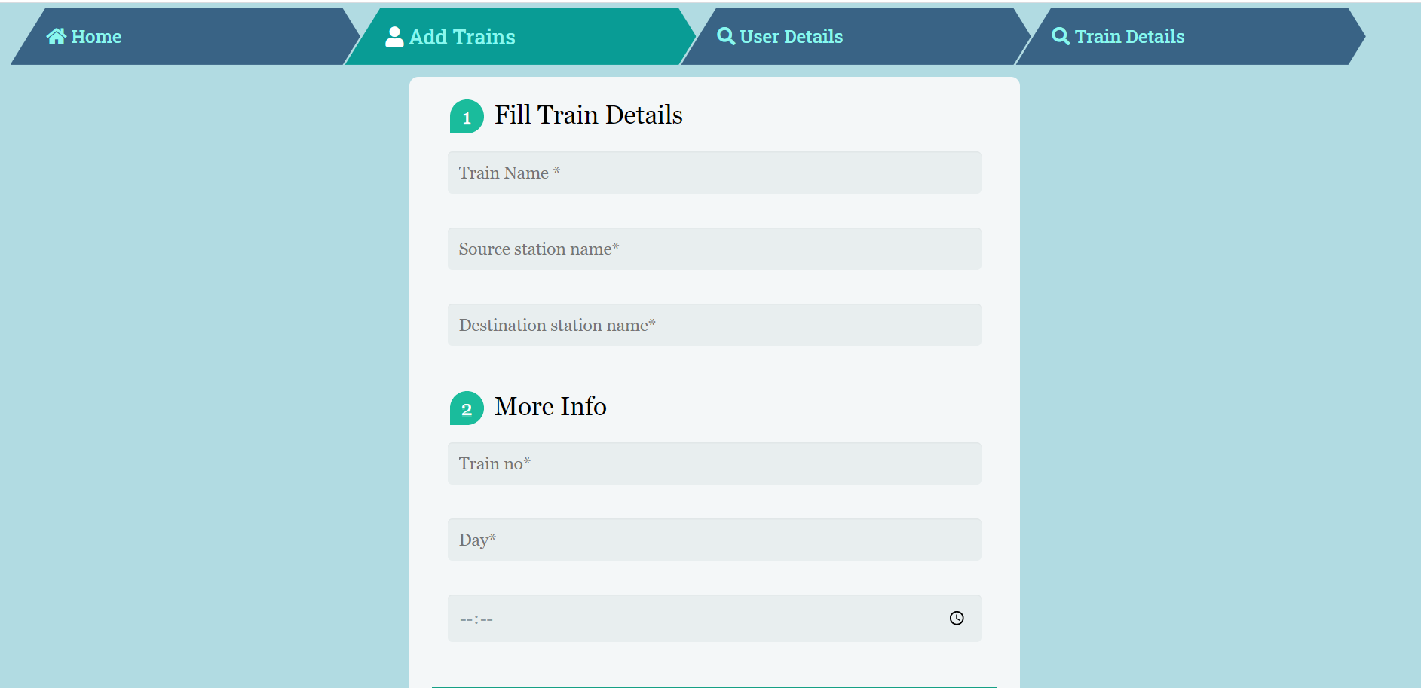

6.All the details need to be provided for successfully adding a train

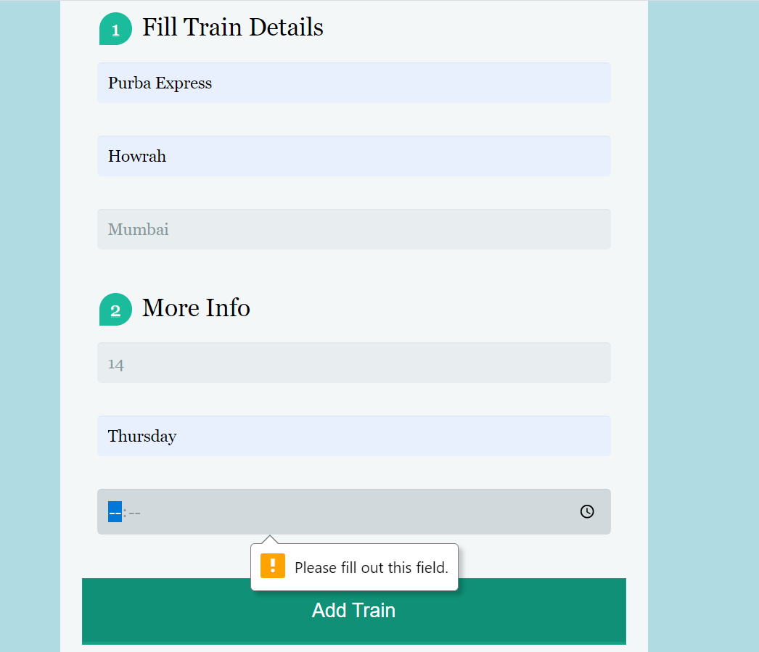

7.Successfully adding trains

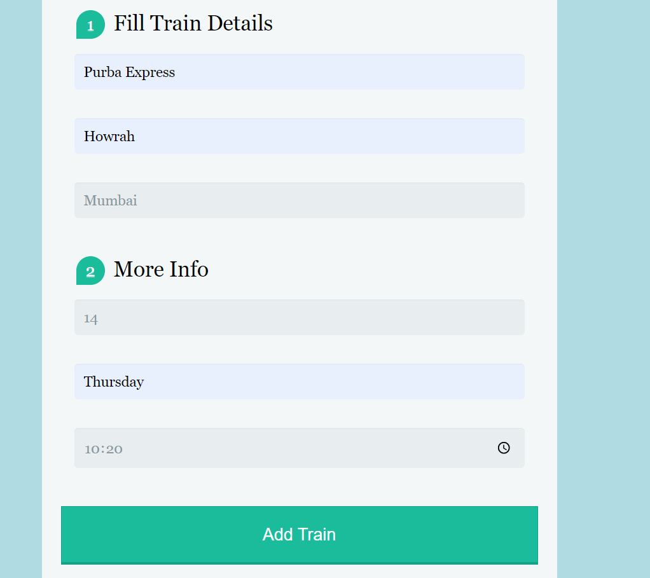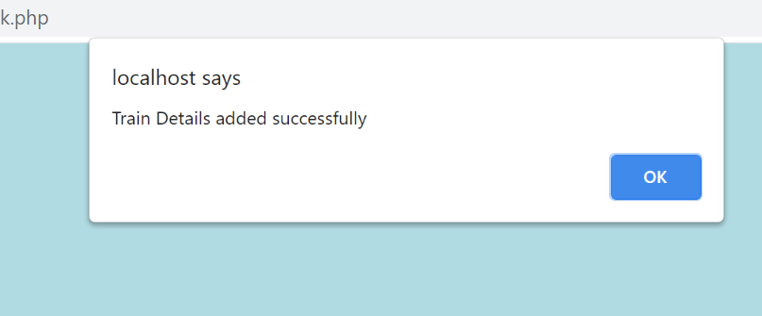

8. Train Details Module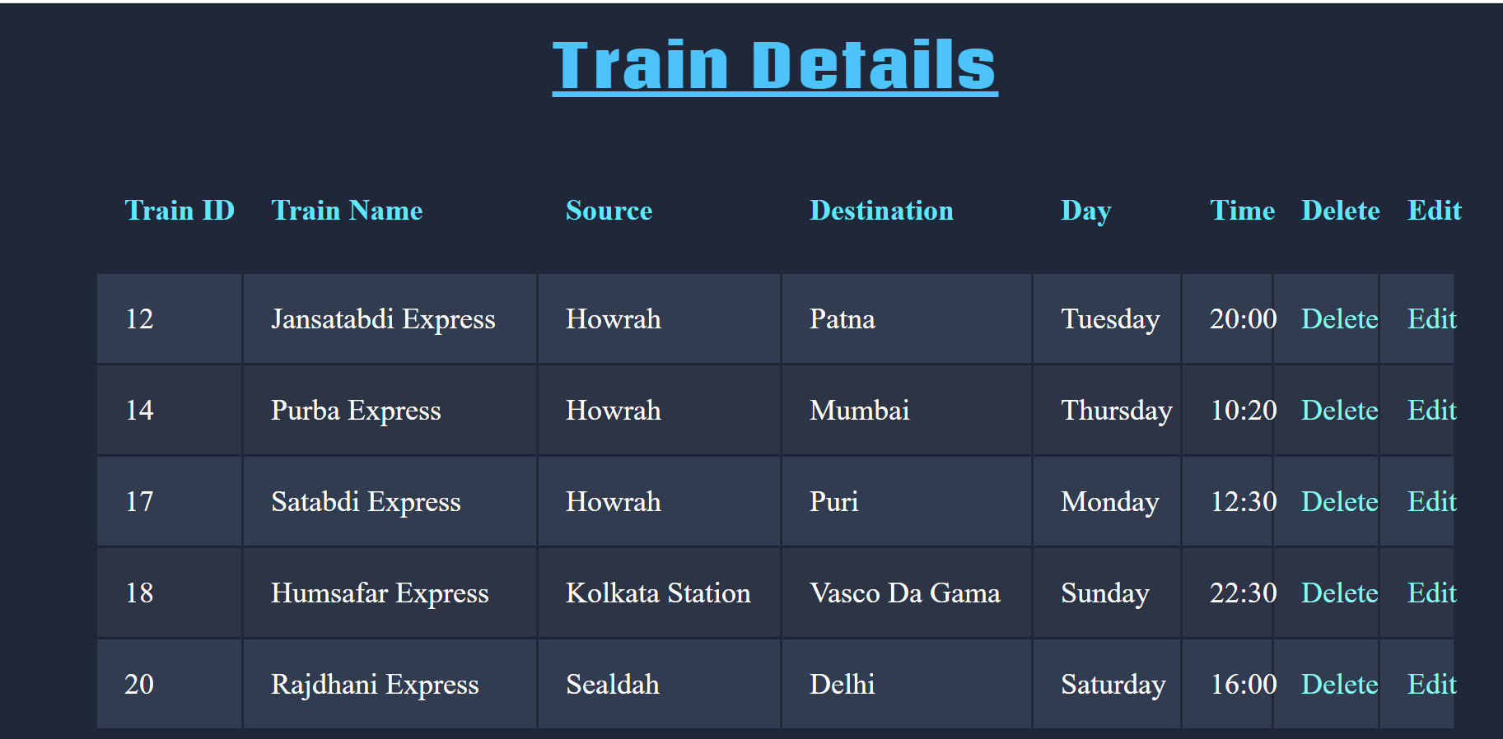

9.Deleting a train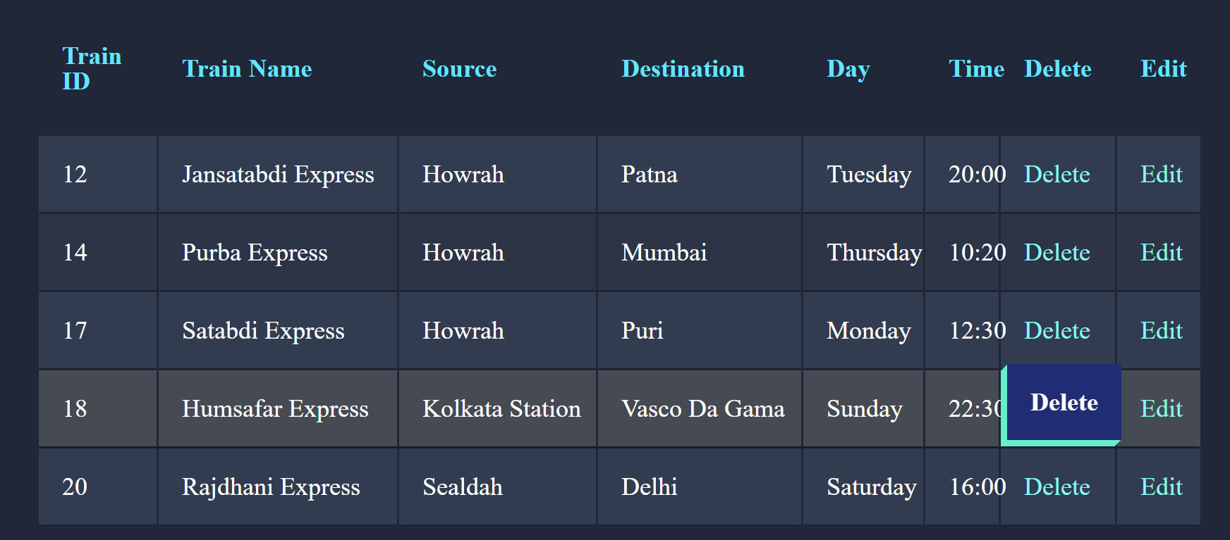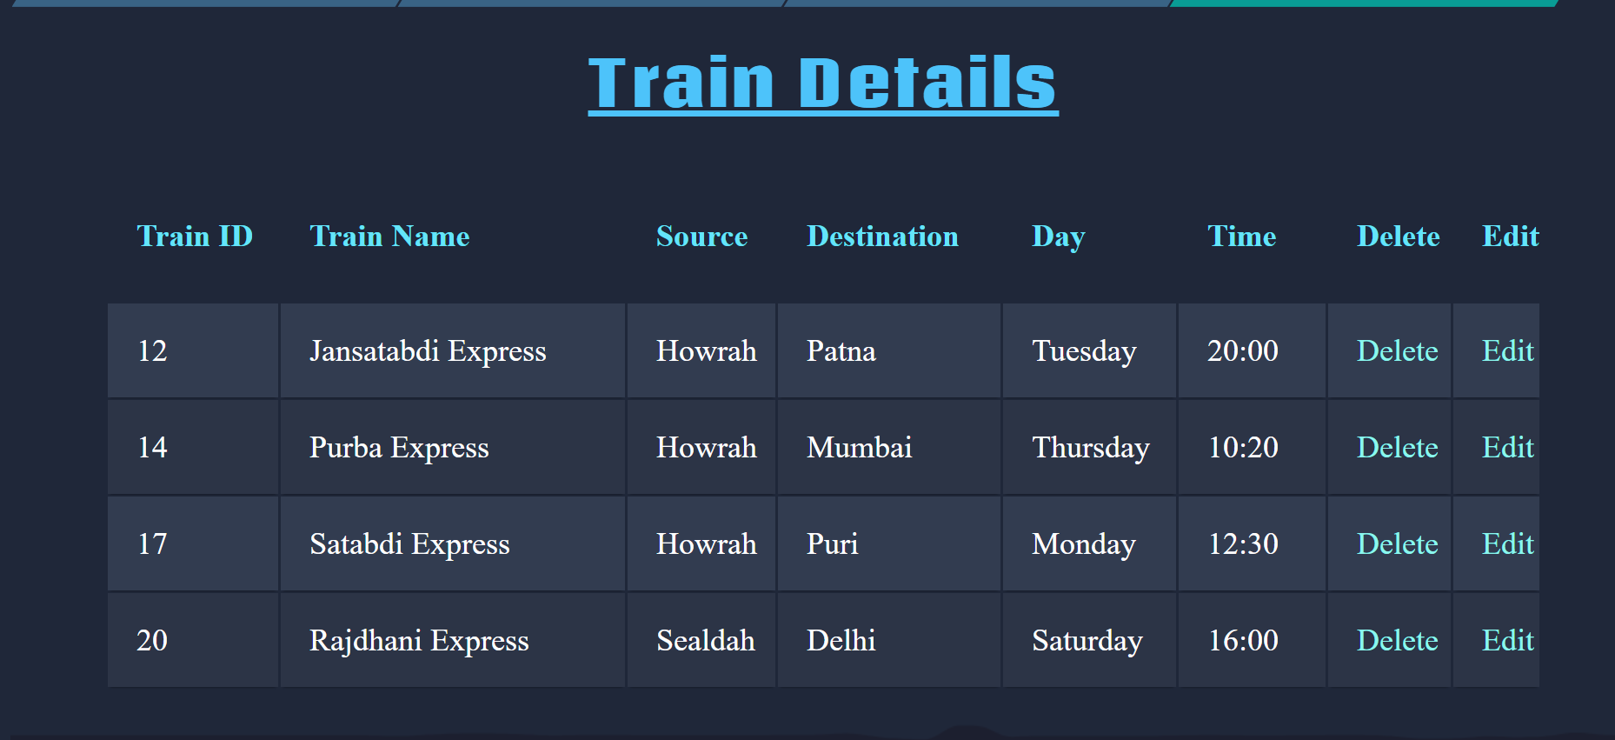

10. Editing a train’s details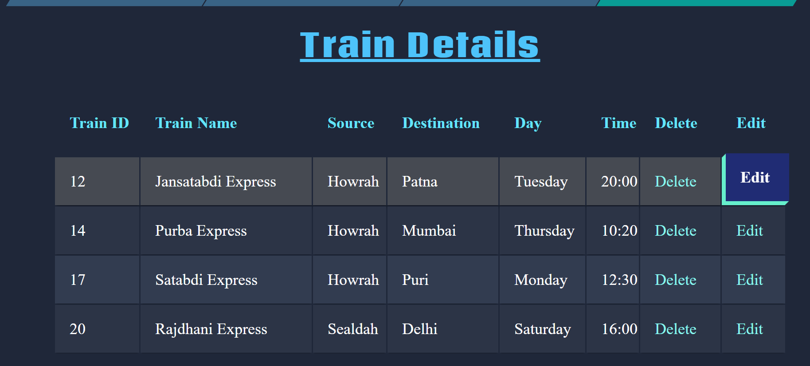

11. Editing form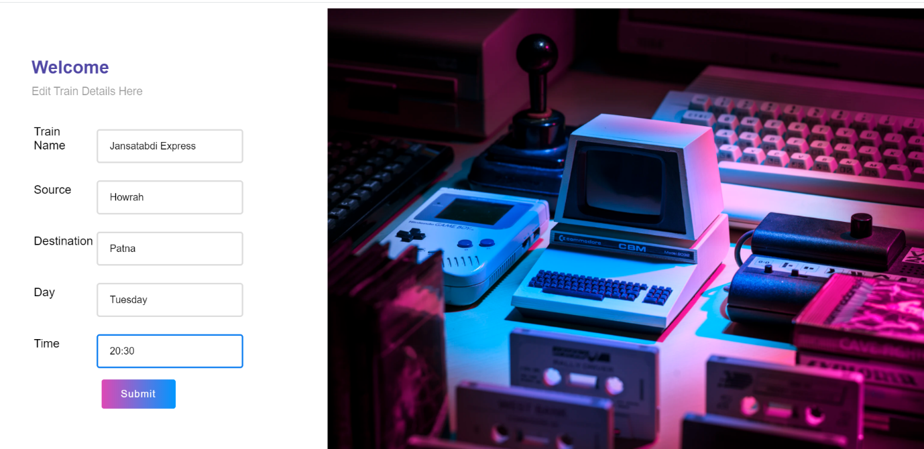

12. successfully edited the time of Jansatabdi Express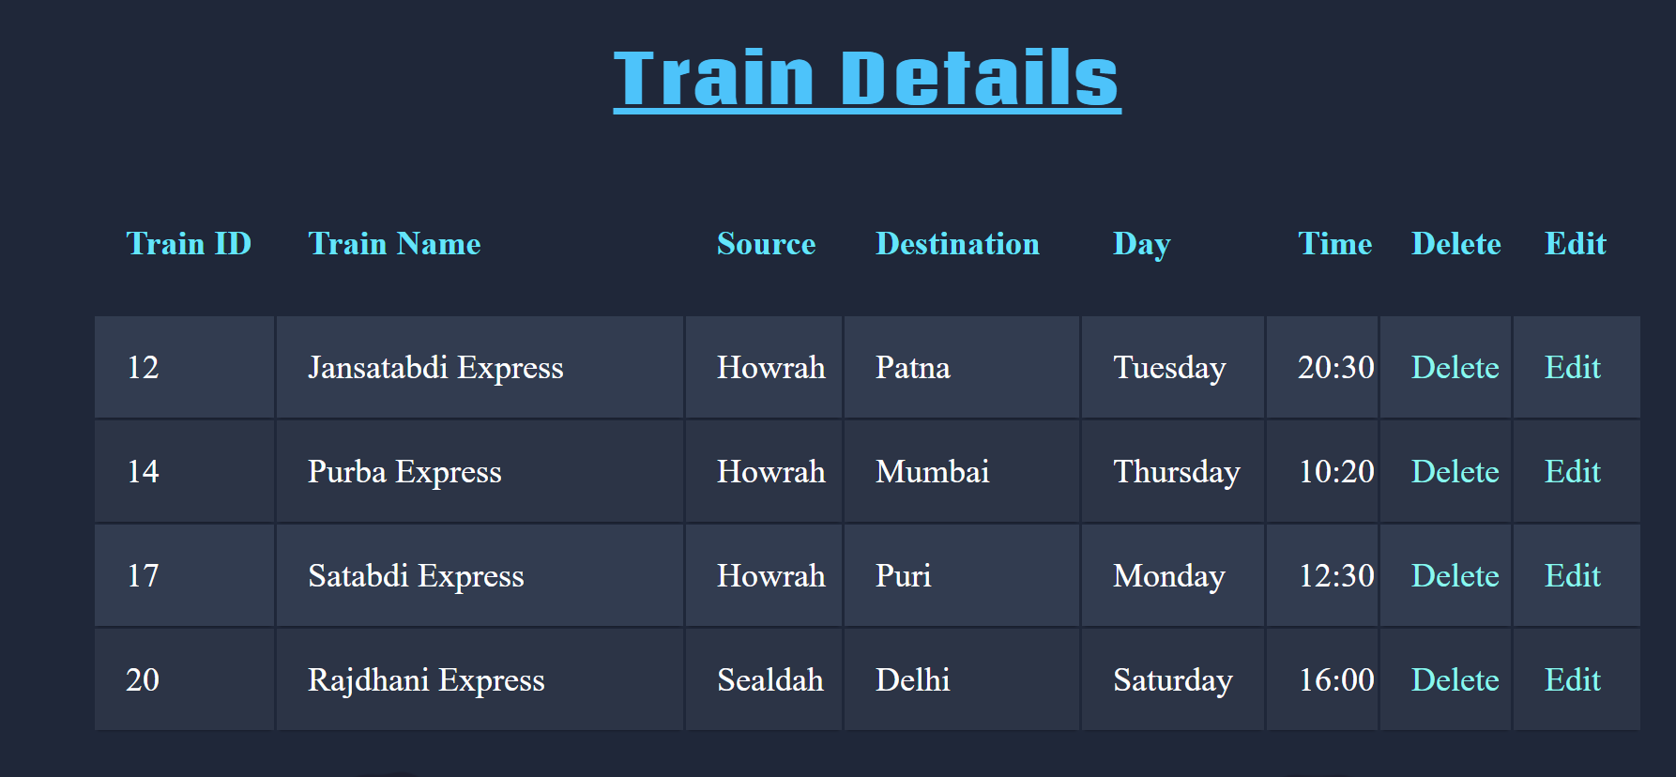

13. User Details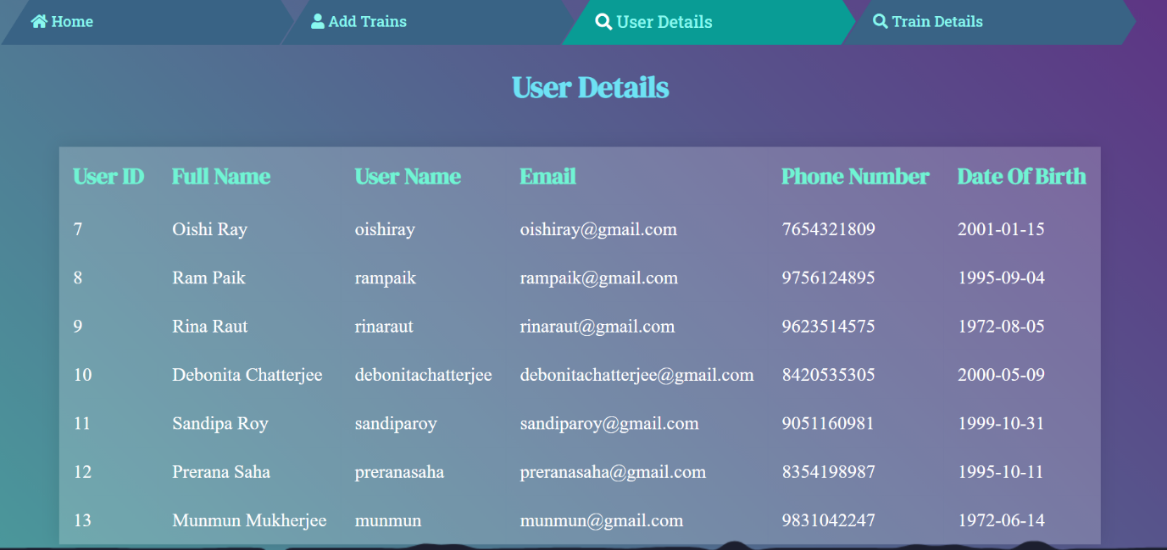

14. Logout of Admin

